 | League City Ladies Auxiliary of the Knights of Columbus | 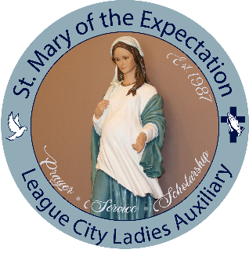

2022 Scholarship Application
DEADLINE for Scholarship Application is Thursday, May 12, 2022. No exceptions.
Catholic Faith Formation is required to be completed for eligibility.
Section below labeled “Additional Information Required” must be submitted with this application.
Incomplete applications will not be considered.
Information on this application must be completed by the applicant.
Questions and completed applications can be emailed to Star Hill (shill77571@gmail.com) or Maria Storey (jmariastorey@hotmail.com). Email applications should be printed, signed and in .pdf format.
Completed applications can also be mailed or dropped off at the Church office.
If you intend to email your application please note you must drop off your photo at the Church office.
Last name |  |  |  |  | First Name |  |  |  | Middle Name
Street Address
City/State/Zip code
Home Phone |  |  |  |  |  |  | Mobile Phone
Email
Graduating High School
Father’s Last name |  |  |  |  |  | Father’s First Name
Street Address
City/State/Zip code
Home Phone |  |  |  |  |  |  | Mobile Phone
Email
Mother’s Last name |  |  |  |  |  | Mother’s First Name
Street Address
City/State/Zip code
Home Phone |  |  |  |  |  |  | Mobile Phone
Email
Please list all siblings name and age below
I hereby make application for a scholarship to be used while attending the university (college, trade or technical school, etc.) for the Fall of 2022 semester listed below.
My intended major is listed below. Applicants are required to attend for minimum of 9 credit hours to be eligible.
Catholic Faith Formation
I have been a member of St. Mary of the Expectation Church since (please provide the year):
Sacrament |  | Parish |  |  |  |  |  |  |  | Year(s)
First Communion
Confirmation
CCE Attendance

By signing this application, I understand that failure to meet all of the Sacramental requirements listed above or submitting a late application will result in disregard of this application. I declare upon my honor that the aforementioned statements and attachments are all true and correct to the best of my knowledge and belief.

Signature | Date

Submission of this application does not guarantee a scholarship will be awarded to you.

ADDITIONAL INFORMATION REQUIRED:
- In your own words, please tell us in no less than one page “What Your Catholic Faith and Experiences mean to You”.
- On a separate page list all specific activities YOU have participated in at St. Mary’s. (Examples: Fish Fry, bazaar, assist with vacation bible school, altar server, etc.)
- On a separate page list all YOUR civic and other faith-based activities. (Examples: Habitat for Humanity, City Trash pick-up, Harvey recovery, scouts, etc.)
- Attach a 4 x 6 photo of the applicant only. This photo will be displayed in the church vestibule.

It is an honor to be able to provide scholarships to our St. Mary High School Students. Good luck and may the Lord bless you and your family.

